create table stud_record(

roll_no int primary key,

name varchar(25),

math int ,phy int,chem int,

check(math between 0 and 50),

check(phy between 0 and 25),

check(chem between 0 and 25));

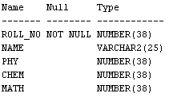

INSERT INTO stud_record VALUES(1, 'Anandu',23,22,48);

INSERT INTO stud_record VALUES(2,'Ankit',12,10,18);

INSERT INTO stud_record VALUES(3,'Chandrapal',19,23,25);

INSERT INTO stud_record VALUES(4,'Megha',15,20,40 );

INSERT INTO stud_record VALUES(5,'Christina',18,16,25);

INSERT INTO stud_record VALUES(6,'Maddie',20,18,27);

INSERT INTO stud_record VALUES(7,'Ryan',24,18,42);

INSERT INTO stud_record VALUES(8,'Elle',25,25,48);

INSERT INTO stud_record VALUES(9,'Clara',21,21,48);

INSERT INTO stud_record VALUES(10,'Marije',10,21,50);

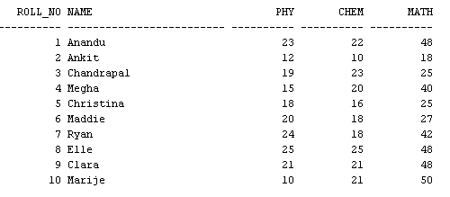

select avg(phy) from stud_record;

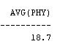

select max(math) as highest_max_marks from stud_record;



select name, math as highest_max_marks from stud_record

where math in (select max(math) from stud_record);



select min(chem) Lowest_mark_chemistry from stud_record;



select count(phy) from stud_record

where phy>=12;



select * from stud_record

where phy>=12 and chem >= 12 and math>=25;

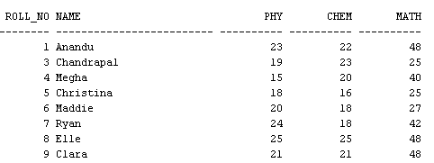

alter table stud_record

add result char(4) default 'fail';

update stud_record

set result='pass'

where chem>=12 and math>=25 and phy>=12;

alter table stud_record

add total int default 0;

update stud_record

set total=chem+phy+math;

select * from stud_record

order by total desc;

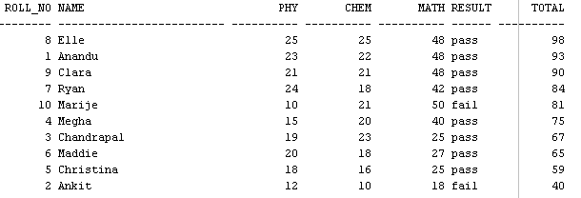

select (count(math))*10 as pass_percent_math from stud_record

where result='pass';



select (count(result))*10 as total_pass_percent from stud_record

where result='pass';



select avg(total) as class_avg from stud_record;



select count(result) as passed from stud_record

where result='pass';

